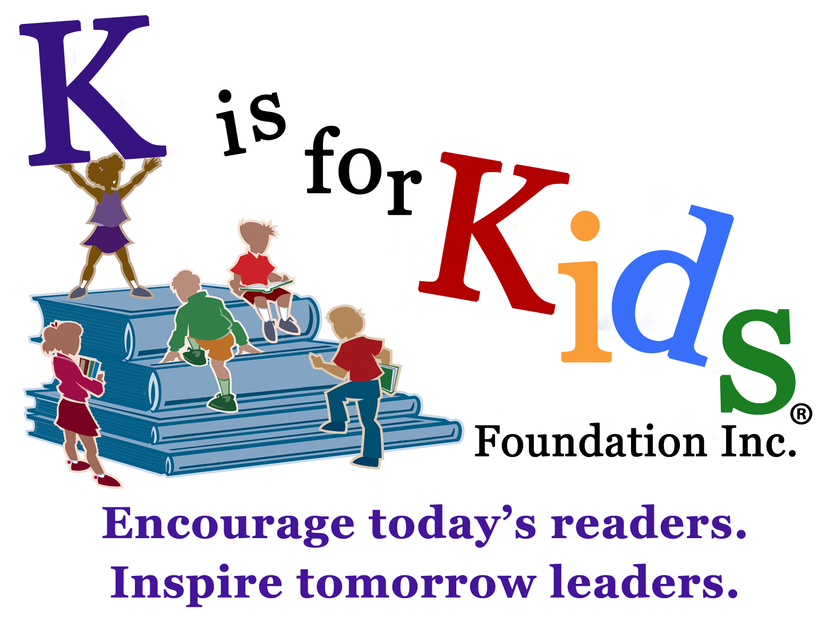 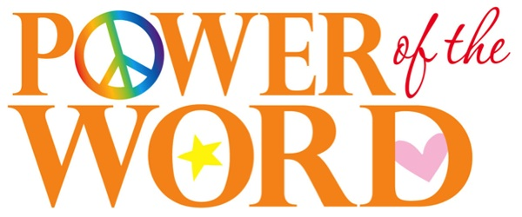 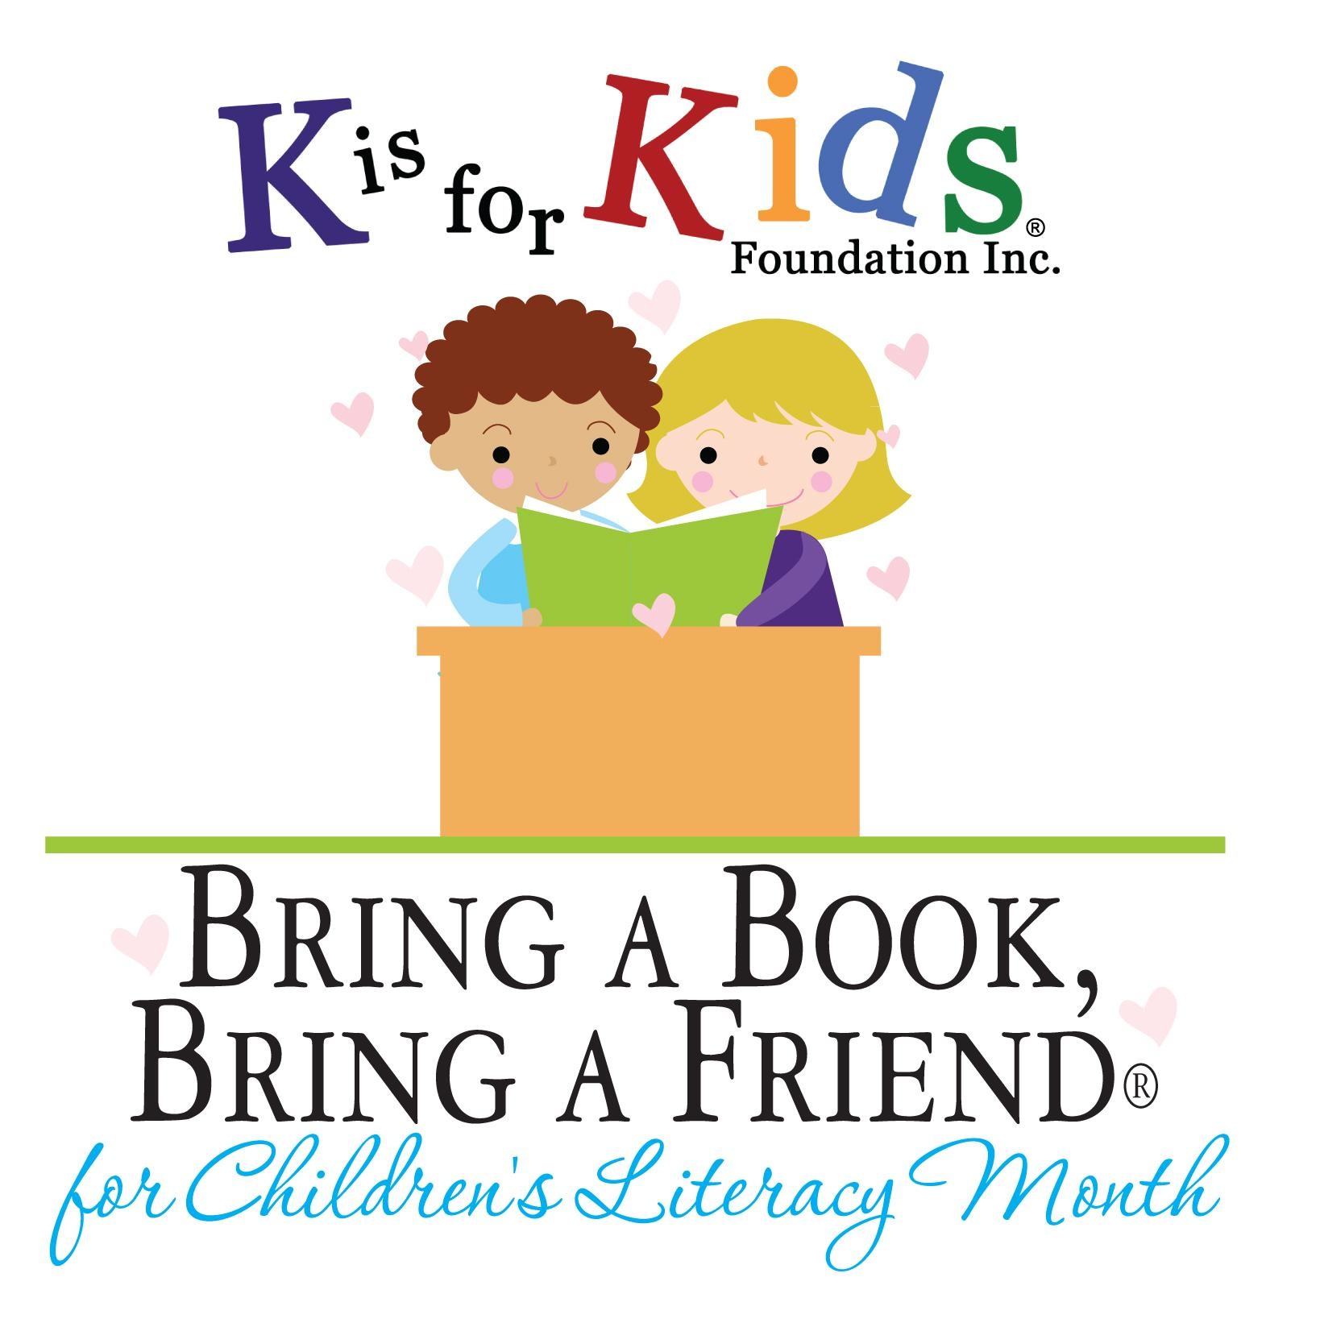

**News Release April 7, 2013**

**Contact Karen@KisforKids.org**

**239.596.KIDS**

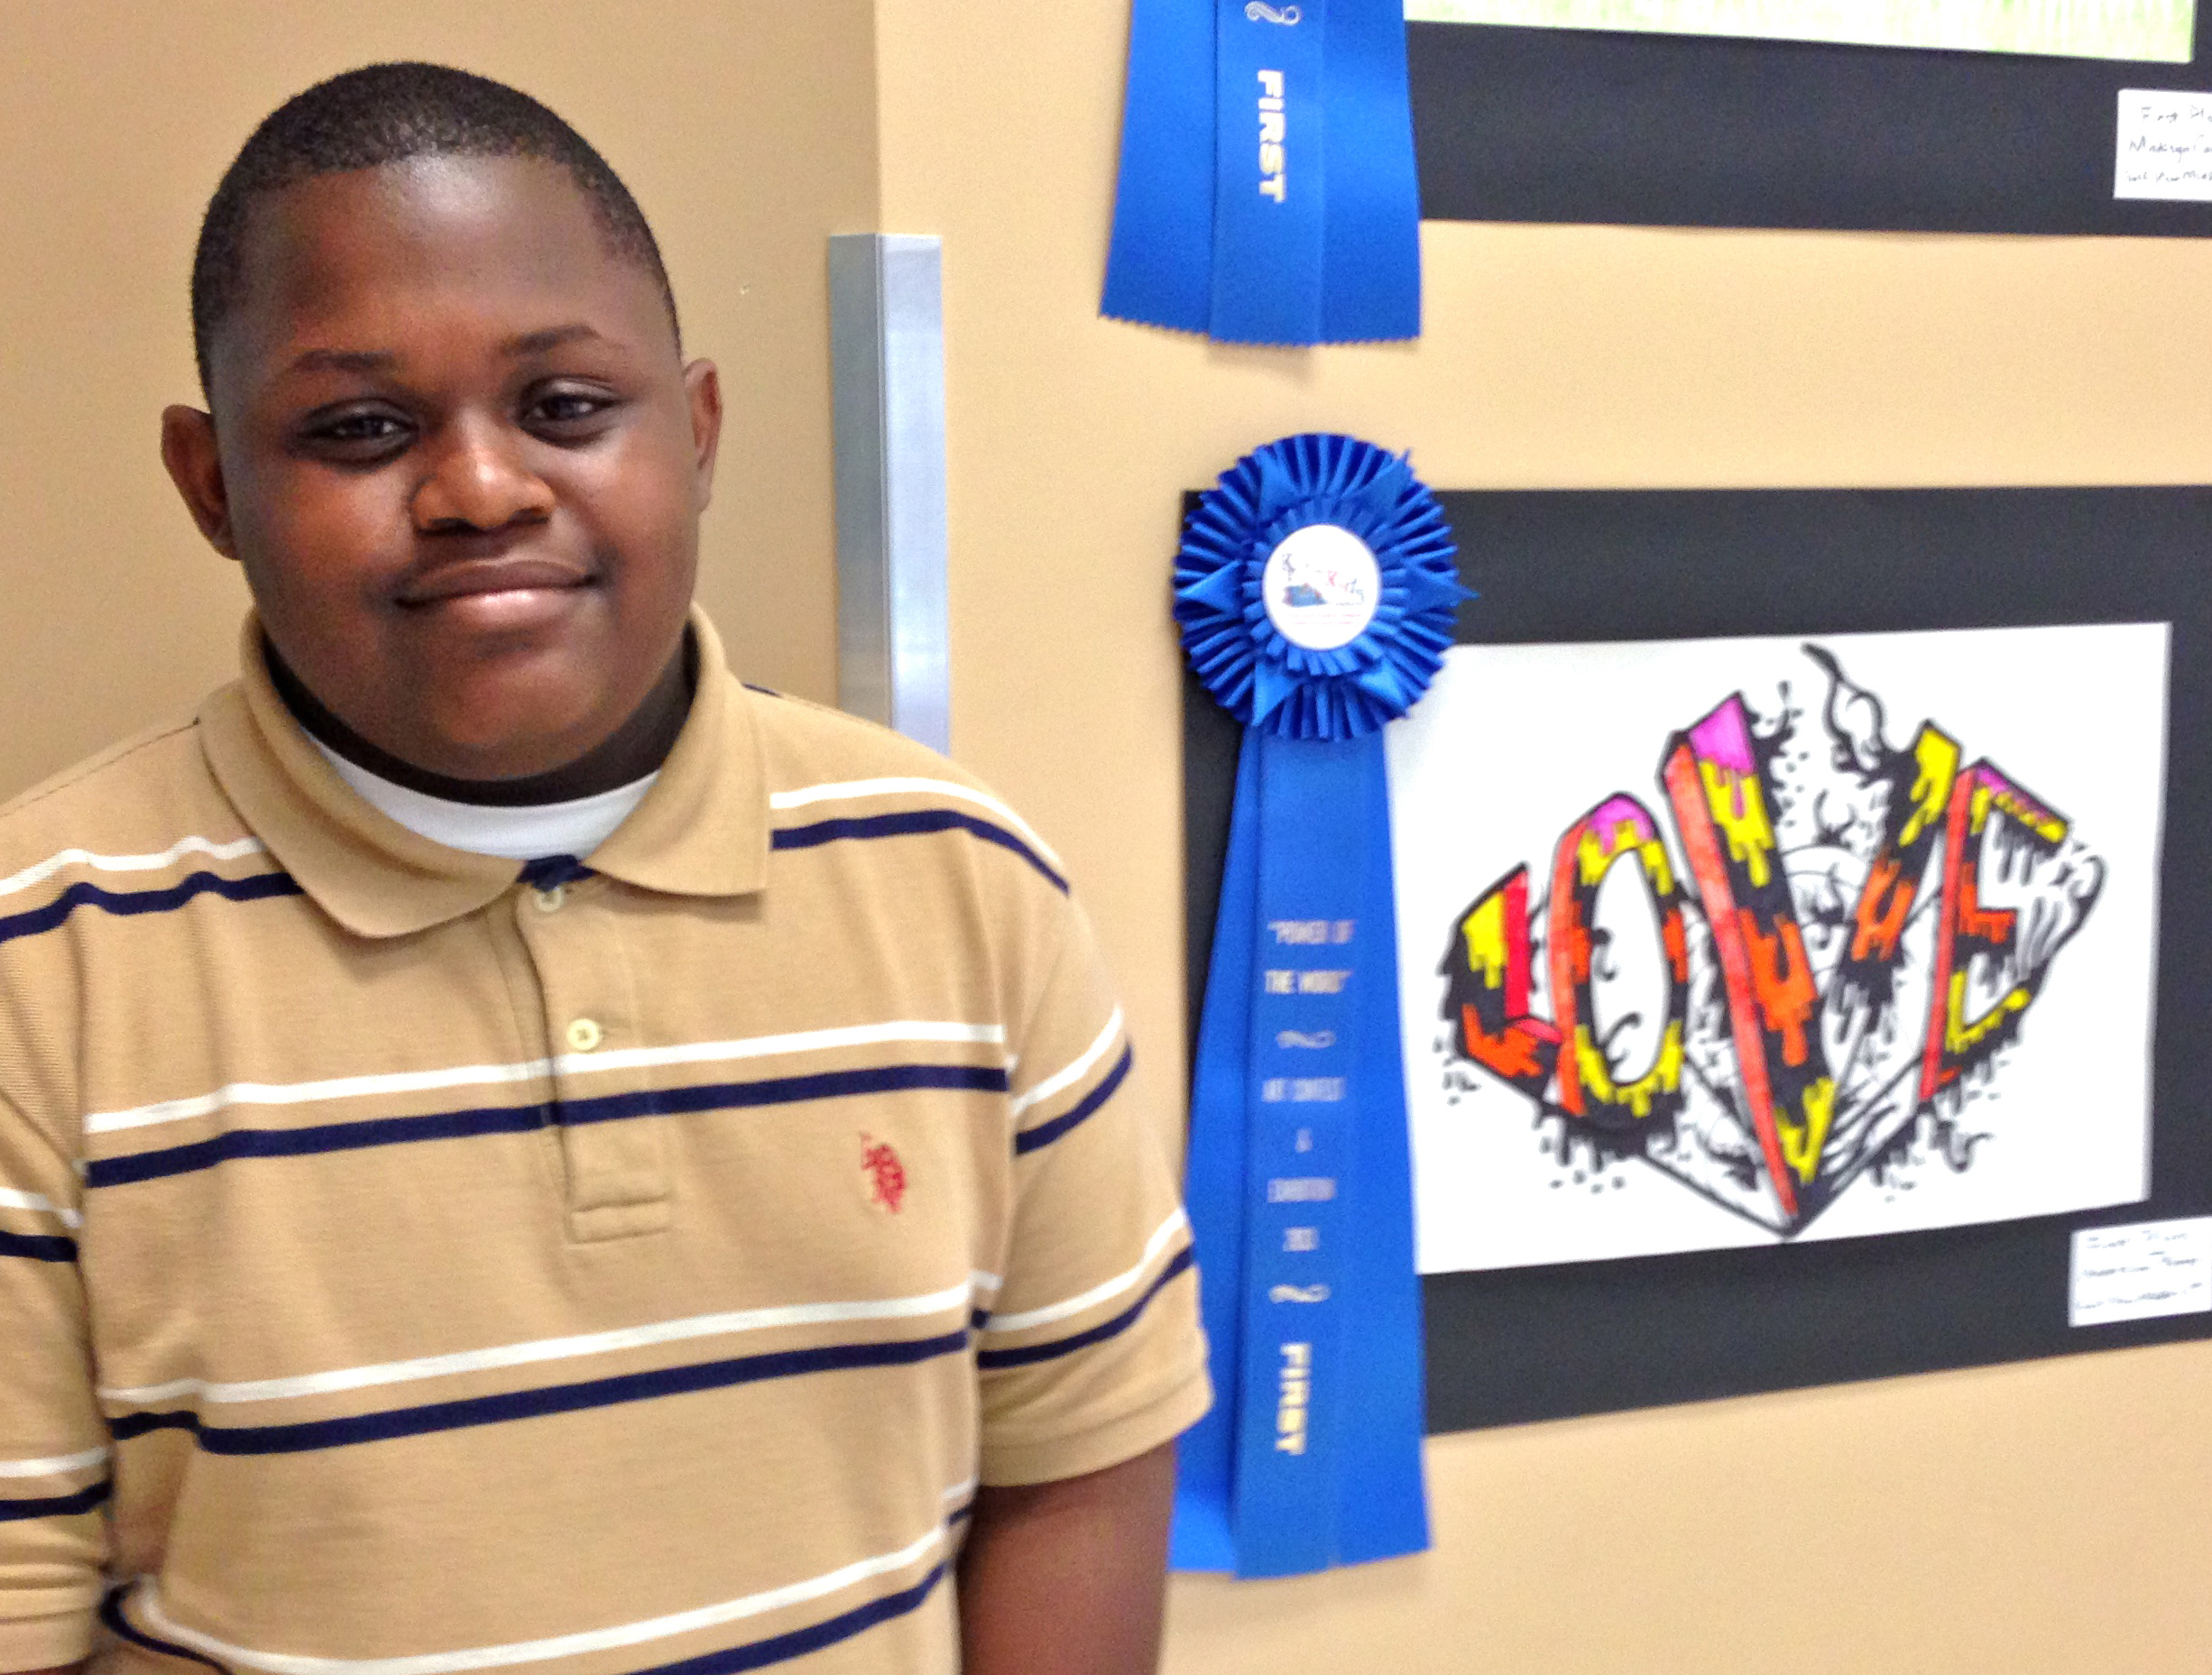

**Fiery "Love" Burns Up the Competition in "Power of the Word" Art Contest**

Andrezione “Dre” Perry had never entered an art contest before, so the Gulfview Middle School student was surprised to learn his fiery “LOVE” had burned up the competition and placed first in the “Power of the Word” Traveling Art Exhibition. With mom and family beaming beside him, the sixth grader patiently posed for pictures at the opening reception of the exhibition, now being shown at the Vineyard Community Center in Naples.

Sponsored by K is for Kids Foundation, a local nonprofit organization promoting children’s literacy and leadership, the contest offers middle school students a unique opportunity to visually express the power of words.  Presented in partnership with the Fine Arts Department of Collier County Public Schools, the Naples Art Association, and Collier County Parks and Recreation, the contest is in its third year.  Twenty-four finalists were selected for the exhibition from over 100 entries.

Judges gave Dre top marks in the single word category for his use of perspective and contrast, and the complimentary color scheme that gave the word more “pop.”  “Dre's  art exemplifies the raw talent of 'tweens and teens in our community just waiting to be discovered and developed," said K is for Kids Founder Karen Clawson. "His work is similar to art that you might see on the cover of a music CD; it has great impact."

Madisyn Campbell, a seventh grade student also at Gulfview Middle, placed first in the multiple word category with her playful interplay of prose and art in “Ladybug".

Two seventh-grade Manatee Middle School students garnered second place in the contest.  Briana Zacarias’ multimedia artwork also won the Teens Choice award for her imaginative use of crayons and paper to craft the word “Color”.  Jessica Mayorcia won the judges’ attention with her illustrated “Dance in the Rain” piece.

First through fourth place finishers and two honorable mentions in each category took home prize ribbons and art supplies.  The top two winners also received complimentary gift certificates to Earth and Fire Ceramic Studio.

 The Vineyards Community Center is located at 6231 Arbor Boulevard in Naples.  The center is open Monday through Friday 9 a.m. to 9 p.m. and on Saturday 9 a.m. to 5 p.m.  For more information, call (239) 353-9669 or K is for Kids at (239) 596-KIDS (5437).  To learn more about the foundation, visit [www.KisforKids.org](http://www.kisforkids.org/).

About K is for Kids Foundation

**"Encourage today's readers.  Inspire tomorrow's leaders."**  
K is for Kids Foundation is a teen volunteer-based 501(c)(3) nonprofit organization promoting children's literacy and leadership. Its teens and volunteers teach kids that reading is fun.  Each year the foundation partners with community leaders and authors to engage children early and often about the excitement of reading and the power of words.  From toddlers to teens, K is for Kids' mission is to give kids in need more books to read.